**1.Design any creative application from the exercises that have been taught to you in this lab. Such as POS systems for any Pharmacy, or any grocery store, or BBQ restaurant, or Pizza Hut or any application which you like.**

Source Code:

**from tkinter import\***

**from tkinter import ttk**

**from tkinter import messagebox**

**import pypyodbc**

**root=Tk()**

**#variable**

**IDvar=StringVar()**

**Namevar=StringVar()**

**Phonevar=StringVar()**

**Addressvar=StringVar()**

**def display():**

**conn = pypyodbc.connect(r'Driver={Microsoft Access Driver (*.mdb)};', DBQ='d:\std.mdb;')**

**cursor = conn.cursor()**

**cursor.execute("select * from student ORDER by ID ")**

**rows = cursor.fetchall()**

**if len(rows) != 0:**

**for row in rows:**

**stable.insert('', END, values=row)**

**conn.commit()**

**conn.close()**

**def add_std():**

**conn = pypyodbc.connect(r'Driver={Microsoft Access Driver (*.mdb)};', DBQ='d:\std.mdb;')**

**cur = conn.cursor()**

**cur.execute( f"INSERT INTO student (ID,Name,Phone,Address) values('{IDvar.get()}','{Namevar.get()}','{Phonevar.get()}','{Addressvar.get()}')")**

**conn.commit()**

**display()**

**messagebox.showinfo("One record has been added")**

**conn.close()**

**def del_std(self):**

**conn = pypyodbc.connect(r'Driver={Microsoft Access Driver (*.mdb)};', DBQ='d:\std.mdb;')**

**cur = conn.cursor()**

**cur.execute(f"DELETE FROM student where ID='{self.IDvar.get()}'")**

**conn.commit()**

**self.display()**

**messagebox.showinfo("hello", 'One record has been deleted')**

**conn.close()**

**def upd_std(self):**

**conn = pypyodbc.connect(r'Driver={Microsoft Access Driver (*.mdb)};', DBQ='d:\std.mdb;')**

**cur = conn.cursor()**

**cur.execute(f"UPDATE student set Address='{self.Addressvar.get()}' where ID='{self.IDvar.get()}'")**

**conn.commit()**

**self.display()**

**messagebox.showinfo("hello", 'One record has been Updated')**

**conn.close()**

**t=Label(root,text="Student Management System",font=("times new roman",40,"bold"),bg="gold",fg="red",bd=10)**

**t.pack(side=TOP,fill=X)**

**m=Frame(root,bd=4,bg='grey')**

**m.place(x=20,y=100,width=450,height=700)**

**l1=Label(m,text="std ID",font=("times new roman",15,"bold"),bg="yellow",width=10).grid(row=0,column=0,padx=10,pady=10)**

**l2=Label(m,text="Std name",font=("times new roman",15,"bold"),bg="yellow",width=10).grid(row=1,column=0,pady=10)**

**l3 = Label(m, text="Phone" ,font=("times new roman",15,"bold"),bg="yellow",width=10).grid(row=2, column=0, pady=10)**

**l4 = Label(m, text="Address" ,font=("times new roman",15,"bold"),bg="yellow",width=10).grid(row=3, column=0, pady=10)**

**l5 = Label(m, text="Program" ,font=("times new roman",15,"bold"),bg="yellow",width=15).grid(row=4, column=0, pady=10)**

**l6 = Label(m, text="Comments" ,font=("times new roman",15,"bold"),bg="yellow",width=15).grid(row=5, column=0, pady=10)**

**ID = Entry(m,textvariable=IDvar,width=20)**

**ID.grid(row=0, column=1, pady=15)**

**Name=Entry(m, textvariable=Namevar,width=20)**

**Name.grid(row=1,column=1,pady=15)**

**Phone=Entry(m, textvariable=Phonevar,width=20)**

**Phone.grid(row=2, column=1, pady=15)**

**Address = Entry(m, textvariable=Addressvar,width=20)**

**Address.grid(row=3, column=1, pady=15)**

**b1=Button(m,text="display",bd=8,font=("times new roman",15,"bold"),bg="red",command=display,width=10).grid(row=7,column=0,padx=10,pady=20)**

**b2=Button(m, text="Insert",bd=8, font=("times new roman",15,"bold"),bg="red",command=add_std,width=10).grid(row=7, column=1, pady=10)**

**b3=Button(m, text="Update",bd=8,font=("times new roman",15,"bold"),bg="red", command=upd_std,width=10).grid(row=8, column=0, pady=10)**

**b4=Button(m, text="Delete",bd=8,font=("times new roman",15,"bold"),bg="red",command=del_std, width=10).grid(row=8, column=1, pady=10)**

**program=ttk.Combobox(m)**

**program['values']=("CSIT","BESE","BEEE","BECE")**

**program.grid(row=4,column=1,padx=10,pady=20)**

**comm = Text(m, width=15,height=5)**

**comm.grid(row=5, column=1, padx=15,pady=20)**

**# Another frame**

**m1=Frame(root, bd=4, bg='grey')**

**m1.place(x=450, y=100, width=850, height=700)**

**stable=ttk.Treeview(m1,height=700,columns=("ID","Name","Phone","Address"))**

**stable.pack()**

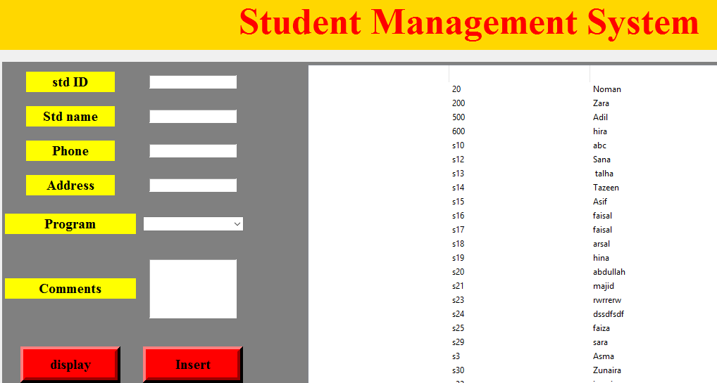**display()**

**root.mainloop()**